CSC501: Module 3 – Project Milestone
10/27/2024
Nathan Rogers

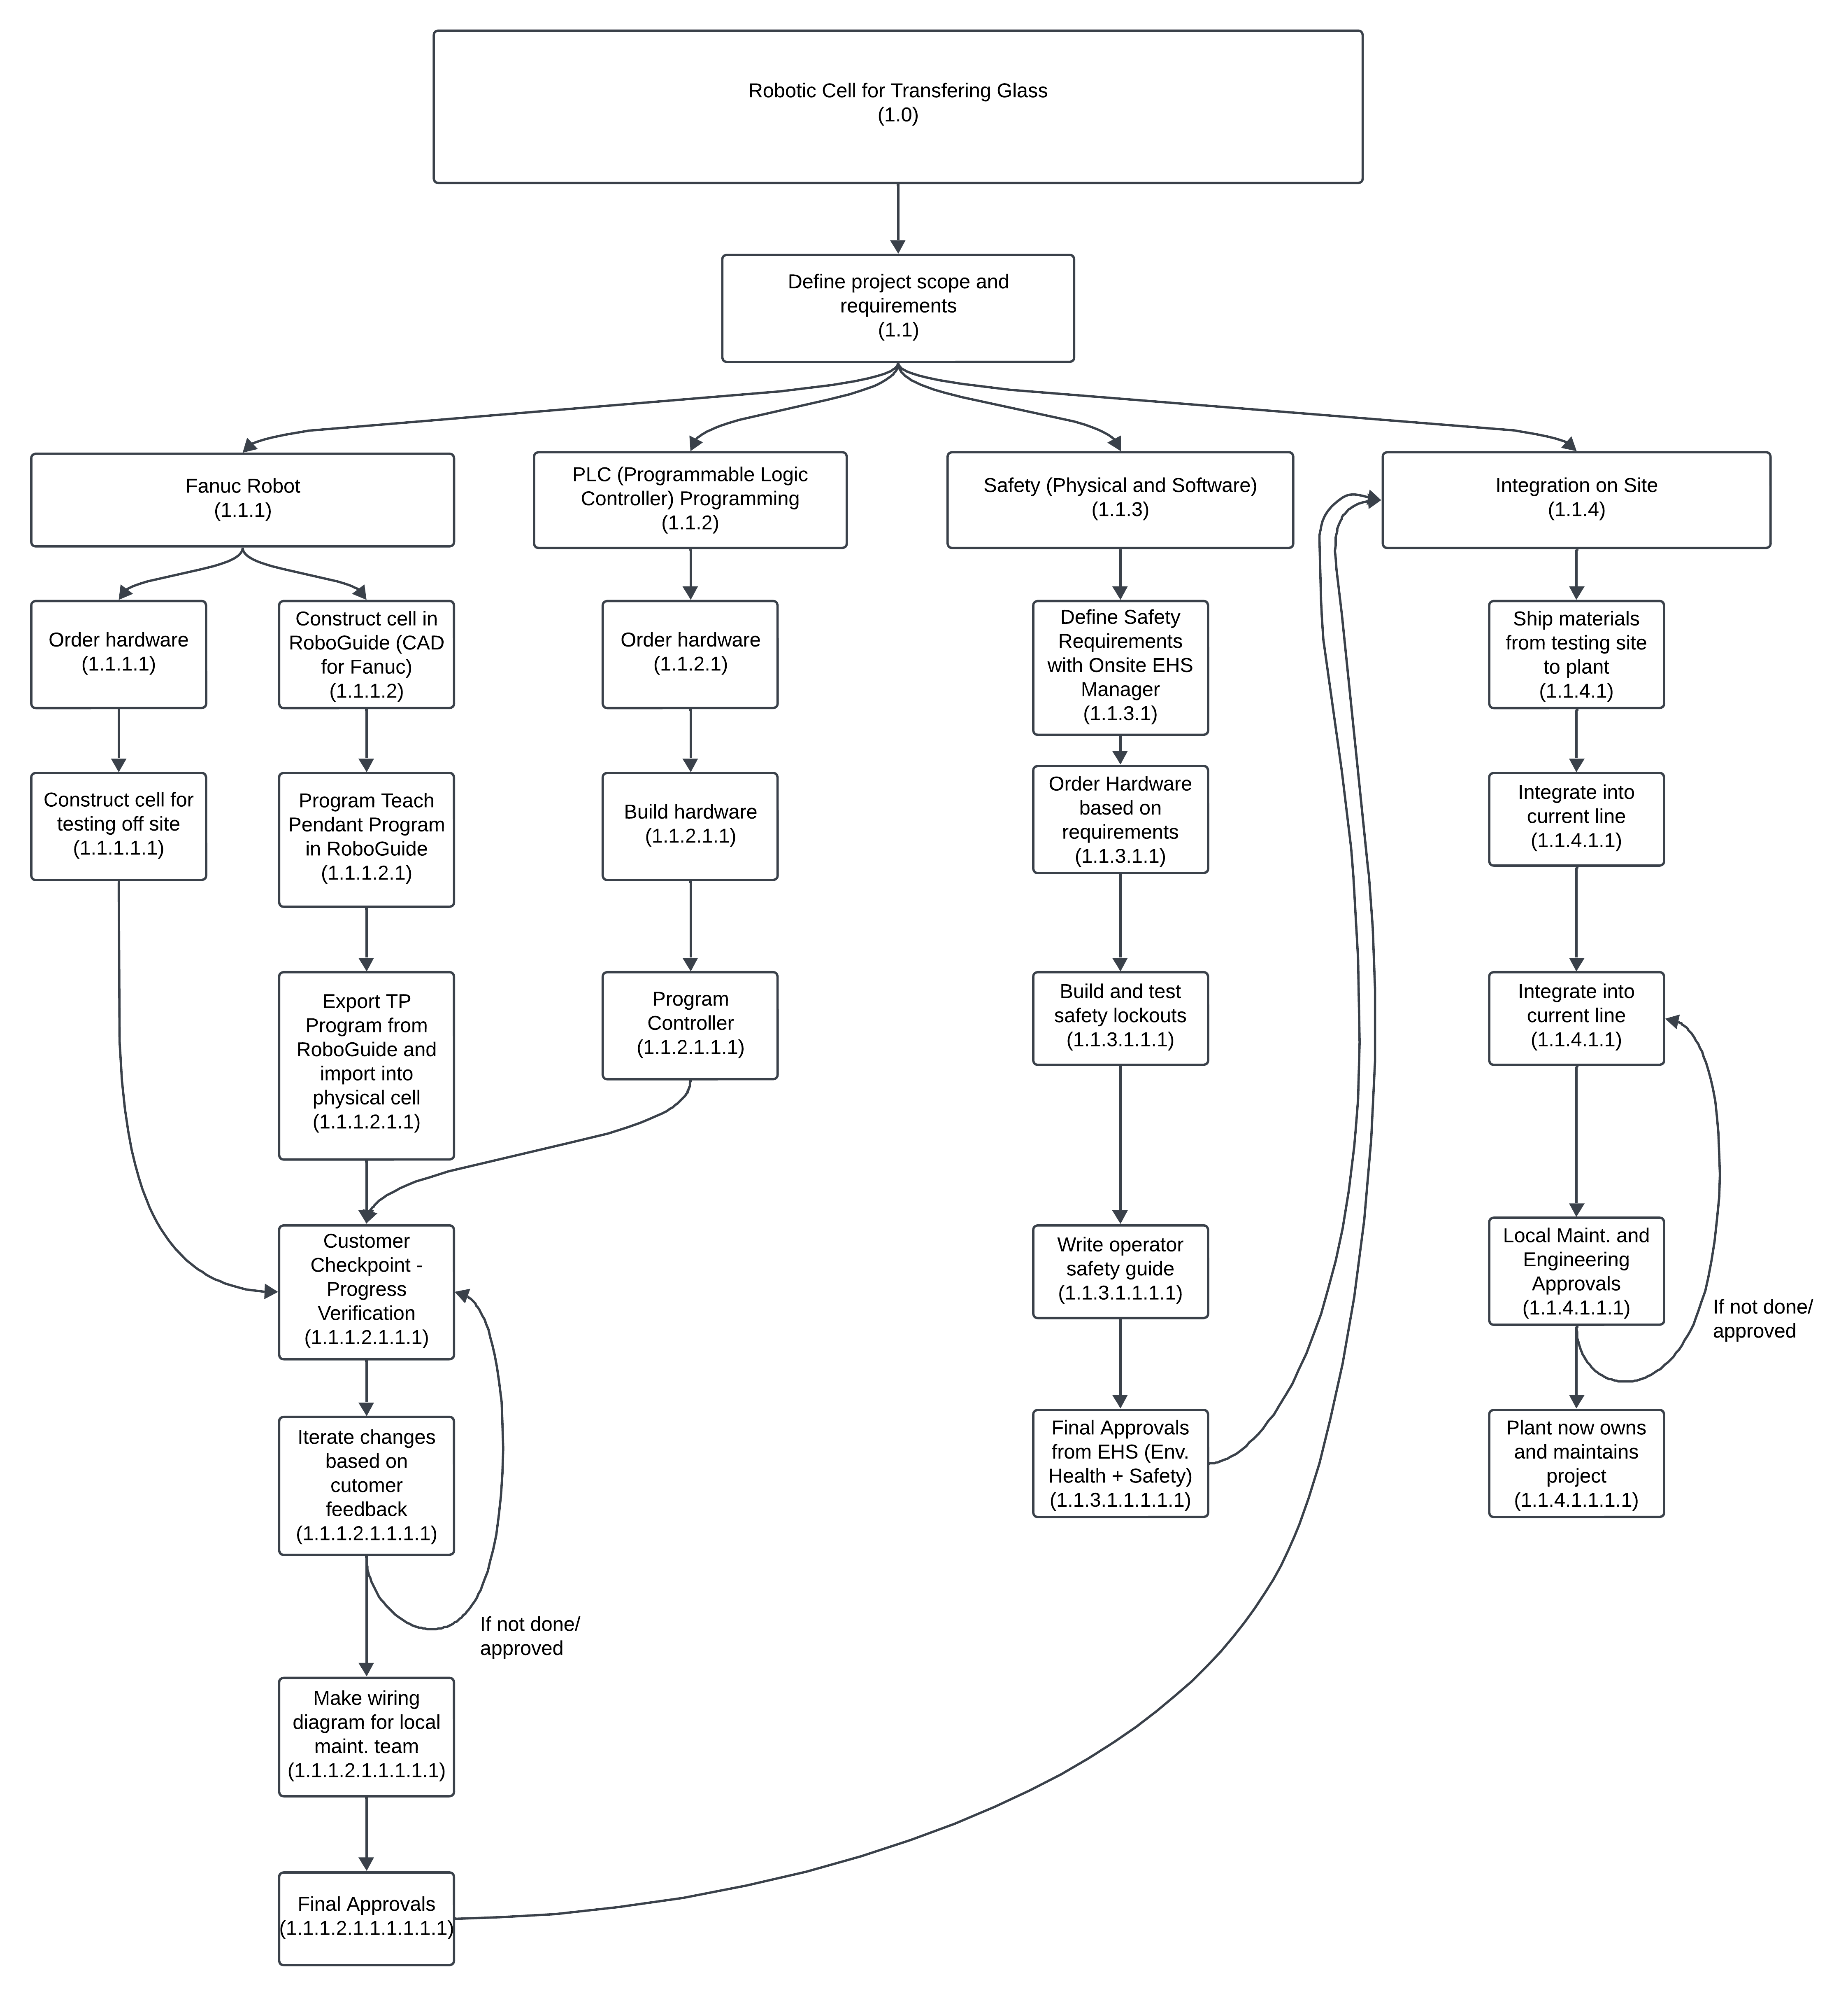

This WBS (Work Breakdown Structure) represents the workflow of how each section of the project will happen. As this project is an agile-oriented project it is difficult to represent all steps and flow of work to be done, however, this represents all the major steps that need to happen in order to fulfill the project requirements, or in other words the full scope of the project.
A project such as this would most likely cost around $800,000. This includes the robot, all hardware, integrators programming time and installation costs. This does build in some cost buffer for extra costs that weren’t accounted for in the initial planning phase.
The full timeline of this project is about 9 – 11 months providing there is no roadblocks such as long purchasing/ordering times, changes or revisions. This timeline accounts for small amounts of time off such as holidays and people getting sick and going on vacation. Now, if the integrator struggles to account for certain things and we disapprove of certain aspects such as programming changes or physical hardware changes, the project could take the full 11 months.
The customer in this case would be us and the integrator would be someone such as STAR (Italian robotics integrating company) who would build the robotic cell and install it in our facility. Due to the nature of these projects, we often don’t design or build these in-house. If we did them in-house, they would indeed cost less, but they would take time away from plant engineering/maintenance that would otherwise be spent maintaining and fixing the productions lines that produce our glass. That being said, these are the steps that we generally take from start to finish when managing this type of project.
For this project there are 3 main areas of development with 1 final step for integration. For the Fanuc Robot and PLC step, as a customer, see the initial mockups of the cell in a program called RoboGuide. This allows them to build the cell and show us how it functions without physical hardware. At the same time the robot required and some materials to get started can be ordered in parallel as approvals can take a while to get. Once everything is constructed and built the programming of the physical hardware can commence. Testing of the hardware and programming can now happen. When the integrators are close to being done, we will go to their facility and do an acceptance testing of the machinery. If all is good, then we will sign off and prepare for on-site installation. However, if we deem it not acceptable, then we will reject the testing, and the integrators will have to revise and change aspects based on our feedback and we will iterate these steps until we accept the machinery.
Once everyone has given their respective approvals, the integrators will ship all equipment to our plant, and we will assist them in installing the robotic cell. This includes the local maintenance department, engineering, and sometimes a third party such as an electrical/mechanical contractor if there are manpower restraints. When everything is in place and tested, we will sign off on the work one final time and then it’s on us to maintain the system with the integrators providing support if something breaks beyond local maintenance is able to fix.

